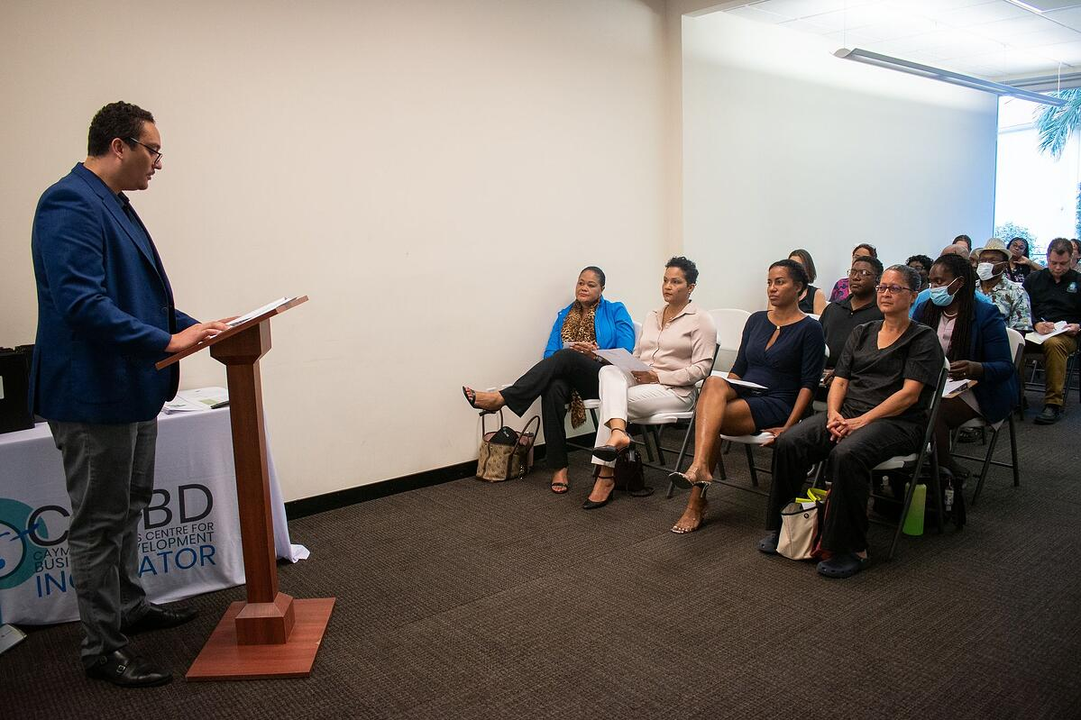

**'Grow Your Business' Programme**

The Cayman Islands Centre for Business Development (CICBD) launched its inaugural 'Grow Your Business' programme — a 15-month initiative, intended to steer businesses through their growth phase. Nineteen small Caymanian businesses representing a diverse array of consumer-facing products and services (including jerk chicken, real estate, beauty, and air conditioning among many others) were chosen to participate.

The entrepreneurs who have founded these businesses will participate in weekly three-hour sessions over 12 weeks between July and October 2022, with training in specific areas that will aid in strategy formulation, decision-making and increasing productivity.

Each business is assigned to a trained Centre for Business Development advisor, who will help the business navigate the 15 months of working closely with the entrepreneur–including identifying challenges and hurdles, creating and implementing a strategy, and monitoring progress.

In a broad sense, the 'Grow Your Business' programme will be a rich source of aggregate data and other insights for the Ministry of Investment, Innovation and Social Development and the wider Cayman Islands Government potentially to introduce reforms (of policy, regulation and/or legislation).